The Companies Act 1985

Company Limited by Guarantee
and not having a share capital

Memorandum
and
Articles of Association
of
Nine Red Presents…

Community Interest Company

The Companies Act 1985
____________________________________

Company Limited by Guarantee
and not having a share capital
____________________________________
Memorandum of Association
Of
Nine Red Presents Community Interest Company

- COMMUNITY INTEREST COMPANY
The Company is to be a community interest company.
- NAME
The Company’s name is Nine Red Presents... Community Interest Company”.
- REGISTERED OFFICE
The Company’s registered office will be in England and Wales
- OBJECTS
The Company’s object is to carry on activities which benefit the community and in particular (without limitation) to
- To promote community cohesion and social & personal harmony, by using performing arts and media to raise the awareness of the history, culture and abilities of all people and highlight the contributions that all races, religions and cultures have made to modern Britain and the world.
- Further education & training in Arts and Cultural diversity and any other activities associated for the progression of this objective.
- Use Arts & Performance to raise awareness and support for community issues, including but not limited to domestic violence, sexual abuse and rape; cultural issues & community cohesion.
- To provide a holistic package of emotional and practical support to those dealing with domestic violence, sexual abuse and rape; whether that is something that's happening now or has happened in the past, providing immediate and free one to one counselling for individuals, in safe and secure surroundings.
- To work inclusively with BME, Disabled and Socially Disadvantaged groups - including victims of abuse; locally, nationally and internationally in the pursuance of objectives (i - iv) above.

- POWERS
The Company has the power to do anything which is incidental or conducive to the furtherance of its object.
- LIMITED LIABILITY
The liability of the Members is limited.
- GUARANTEE
Every Member of the Company undertakes to contribute a sum not exceeding £1 to the assets of the Company if it is wound up during his, her or its membership or within one year afterwards:

(a) for payment of the debts and liabilities of the Company contracted before he, she or it ceased to be a Member;

(b) for the costs, charges and expenses of winding up; and

(c) for the adjustment of the rights of the contributories among themselves.

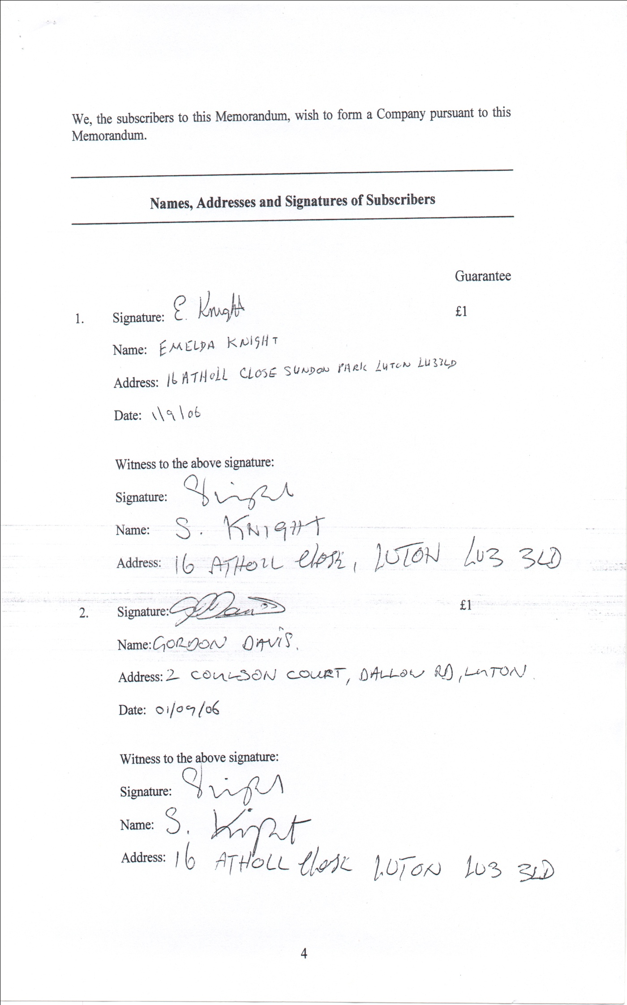
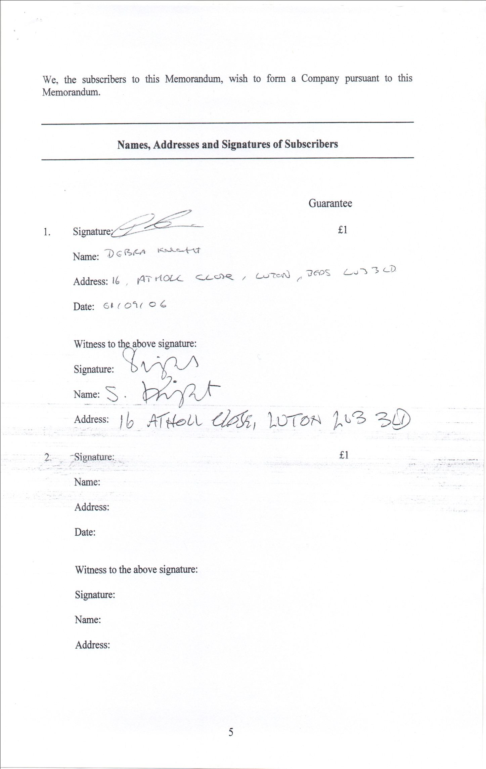

The Companies Act 1985

Company Limited by Guarantee
and not having a share capital

Articles of Association

of
Nine Red Presents...
Community Interest Company

TABLE OF CONTENTS
Subject | Articles

Part One: Definitions and Interpretation
Definitions | 1
Interpretation | 2

Part Two: Asset Lock
Transfer of assets | 3

Part Three: Directors’ Functions
Directors’ general authority to manage the Company | 4
Directors’ general authority to delegate functions | 5
Committees of Directors | 6

Part Four: Decision-making by Directors
Scope of rules | 7
Directors to take decisions collectively | 8
Unanimous decisions | 9
Majority decisions | 10
Meetings of Directors | 11
Conflicts of interest | 12
Records to be kept | 13
Specified number of Directors for majority decisions | 14
Chairing of majority decision making processes | 15
Directors’ discretion to make further rules | 16
Defect in appointment | 17

Part Five: Directors’ Appointment and Terms of Service
Minimum number of Directors | 18
Appointment of Directors | 19
Termination of Directors’ appointment | 20
Directors’ remuneration and other terms of service | 21
Directors’ expenses | 22

Part Six: Appointment of Members
Appointment of Members | 23
Transfer and termination of Membership | 24

Part Seven: General Meetings
Annual general meeting | 25
Other general meetings | 26
Notice | 27
Quorum | 28
Conduct of business – general | 29
Voting procedures | 30
Minutes | 31

Part Eight: Miscellaneous
Company Secretary | 32
Accounts and reports | 33
Notices | 34
Indemnity | 35

PART ONE: DEFINITIONS AND INTERPRETATION
- DEFINITIONS
In these Articles the following terms shall have the following meanings.
Term | Meaning
“1985 Act” | the Companies Act 1985
“2004 Act” | the Companies (Audit, Investigations and Community Enterprise) Act 2004
“address” | in relation to electronic communications, includes any number or address used for the purposes of such communications
“Articles” | the Company’s Articles of Association
“Asset Locked Body” | a community interest company, Charity or Scottish Charity or a body established outside Great Britain (for the purposes of article 3(2)(a), the United Kingdom) that is equivalent to any of those persons
“Chair” | the meaning given in article 15
“Charity” | (except in the phrase, “Scottish Charity”) the meaning given by Section 96 of the Charities Act 1993
“clear days” | in relation to the period of a notice, that period excluding the day when the notice is given or deemed to be given and the day for which it is given or on which it is to take effect
“Company” | Nine Red Presents... Community Interest Company
“Director” | a Director of the Company, including any person occupying the position of Director, by whatever name called
“Directors’ functions” | the meaning given in article 4(1)
“electronic communication” | the meaning given in the Electronic Communications Act 2000
“in writing” | written printed or transmitted writing including by electronic communication
“majority decision” | the meaning given in article 10
“Members” | the members of the Company as defined in the 1985 Act
“Memorandum” | the Company’s Memorandum of Association
“Regulations” | the Community Interest Company Regulations 2005
“Regulator” | the Regulator of Community Interest Companies
“relevant quorum” | the meaning given in article 14(1)
“remuneration” | any reasonable payment or benefit received, or to be received, by a Director or employee of the Company in consideration for that Director’s or employee’s services to the Company, and any arrangement in connection with the payment of a pension, allowance or gratuity to or in respect of any person who is to be, is, or has been a Director or employee of the Company or any of its predecessors in business
“Scottish Charity” | the meaning given in section 1(7) of the Law Reform (Miscellaneous Provisions) Scotland Act 1990
“Secretary” | the individual appointed as Company Secretary under article 32
“subsidiary” | the meaning given in section 736 of the Companies Act 1985
“unanimous decision” | the meaning given in article 9.

- INTERPRETATION

  - Unless the context requires otherwise, words or expressions defined in:

    - the 1985 Act,
    - the 2004 Act, or
    - the Regulations,
have the same meaning in the Articles.

  - Without prejudice to the generality of paragraph (1):

    - “community” is to be construed in accordance with section 35 of the 2004 Act and Part 2 of the Regulations;

    - “financial year” has the meaning given in section 223 of the 1985 Act; and

    - “transfer” includes every description of disposition, payment, release or distribution and the creation or extinction of an estate or interest in, or right over, any property, or, in Scotland, a right, title or interest in or over any property.

  - Unless the context requires otherwise, all references to legislative provisions are to the legislation concerned as amended, repealed, re-enacted or replaced and in force from time to time.

  - Unless the context requires otherwise, words in the singular include the plural and words in the plural include the singular.

  - All headings and explanatory notes are included for convenience only: they do not form part of the Articles, and shall not be used in the interpretation of the Articles.

PART TWO: ASSET LOCK

- TRANSFER OF ASSETS

  - The Company shall not transfer any of its assets other than for full consideration.

  - Provided the condition specified in paragraph (3) is satisfied, paragraph (1) shall not apply to:

    - the transfer of assets to any Asset Locked Body specified in the Memorandum or Articles for the purposes of this article or (with the consent of the Regulator) to any other Asset Locked Body; and

    - the transfer of assets made for the benefit of the community other than by way of a transfer of assets to an Asset Locked Body.

  - The condition is that the transfer of assets must comply with any restrictions on the transfer of assets for less than full consideration which may be set out elsewhere in the Memorandum or the Articles.

  - If:

    - the Company is wound up under the Insolvency Act 1986; and

    - all its liabilities have been satisfied,

then any residual assets shall be given or transferred to the specified Asset Locked Body specified in the Memorandum and Articles for the purposes of this article.

  - For the purposes of this article, the following Asset Locked Body is specified as a potential recipient of the Company’s assets under paragraphs (2) and (4).

Name: TBA

Registered Charity Number [if applicable]: [ ________________ ]

Registered Company Number [if applicable]: [ ________________ ]

Registered Office / Principal office address: [ ________________________________
________________________________________________________________________
________________________________________________________________________
_______________________________________________________________________ ]

[Insert above the relevant details of any Asset Locked Body to which you may wish the Company to be able to transfer assets other than for full consideration and to which you would wish any residual assets of the Company to be transferred if it is wound up.]

PART THREE: DIRECTORS’ FUNCTIONS
- DIRECTORS’ GENERAL AUTHORITY TO MANAGE THE COMPANY
  - The Directors’ functions are:
    - to manage the Company’s business; and
    - to exercise all the powers of the Company for any purpose connected with the Company’s business.
  - The Directors may delegate their functions in accordance with the Articles.
- DIRECTORS’ GENERAL AUTHORITY TO DELEGATE FUNCTIONS
  - Subject to the Articles, the Directors may delegate any of their functions to any person they think fit.
  - The Directors must not delegate to any person who is not a Director any decision connected with:
    - the taking of decisions by Directors; or
    - the appointment of a Director or the termination of a Director’s appointment.
  - Any delegation under paragraph (1) may authorise further delegation of the Directors’ functions by any person to whom they are delegated.
- COMMITTEES OF DIRECTORS
  - Two or more Directors are a “committee” if the Directors have:
    - delegated any of the Directors’ functions to them; and
    - indicated that they should act together in relation to that function.
  - The provisions of the Articles about how the Directors take decisions shall apply, as far as possible, to the taking of decisions by committees.

PART FOUR: DECISION-MAKING BY DIRECTORS
- SCOPE OF RULES
  - References in the Articles to decisions of Directors are to decisions of Directors which are connected with their functions.

  - Except where the Articles expressly provide otherwise, provisions of the Articles about how the Directors take decisions do not apply:
    - when the Company only has one Director; or
    - to decisions delegated to a single Director.
- DIRECTORS TO TAKE DECISIONS COLLECTIVELY
Any decision which the Directors take:
    - must be either a unanimous decision or a majority decision; and
    - may, but need not, be taken at a meeting of Directors.
- UNANIMOUS DECISIONS
  - The Directors take a unanimous decision when they all indicate to each other that they share a common view on a matter.
  - A unanimous decision need not involve any discussion between Directors.
- MAJORITY DECISIONS
  - The Directors take a majority decision if:
    - every Director has been made aware of a matter to be decided by the Directors;
    - all the Directors who indicate that they wish to discuss or vote on the matter have had a reasonable opportunity to communicate their views on it to each other; and
    - a majority of those Directors vote in favour of a particular conclusion on that matter.
  - Paragraph (1)(a) does not require communication with any Director with whom it is not practicable to communicate, having regard to the urgency and importance of the matter to be decided.
  - In case of an equality of votes, the Chair shall have a second or casting vote.
  - A Director who is an alternate director shall be entitled in the absence of his appointer to a separate vote on behalf of his appointer in addition to his own vote.
  - Except as provided by paragraphs (3) and (4), in all proceedings of Directors each Director must not have more than one vote.
  - Directors participating in the taking of a majority decision otherwise than at a meeting of Directors:
    - may be in different places, and may participate at different times; and
    - may communicate with each other by any means.
- MEETINGS OF DIRECTORS
  - Any Director may call a meeting of Directors.
  - Every Director must be given reasonable notice of a meeting of Directors.
  - Paragraph (2) does not require notice to be given:
    - in writing; or
    - to Directors to whom it is not practicable to give notice, having regard to the urgency and importance of the matters to be decided, or who have waived their entitlement to notice.
  - Directors participating in a meeting of Directors:
    - must participate at the same time, but may be in different places; and
    - may communicate with each other by any means.
- CONFLICTS OF INTEREST

  - In this article, a “relevant interest” is:
    - any interest which a Director has in; or

    - any duty which a Director owes to a person other than the Company in respect of,

an actual or proposed transaction or arrangement with the Company.

  - For the purposes of paragraph (1)(a), a Director shall be deemed to have an interest in a transaction or arrangement if:

    - the Director or any partner or other close relative of the Director has an actual or potential financial interest in that transaction or arrangement;

    - any person specified in paragraph (2)(a) is a partner in a firm or limited partnership, or a director of or a substantial shareholder in any Company, which has an actual or potential commercial interest in that transaction or arrangement; or

    - any other person who is deemed to be connected with that Director for the purposes of section 317 of the 1985 Act has a personal interest in that transaction or arrangement.

  - Subject to paragraph (8)(b), a Director who has a relevant interest must disclose the nature and extent of that interest to the other Directors.
  - Subject to paragraphs (5) and (6), when the Directors take a majority decision on any matter relating to a transaction or arrangement in which a Director has a relevant interest:

    - no Director who has such a relevant interest may vote on that matter; and

    - for the purposes of determining whether a relevant quorum is present, or whether a majority decision has been taken in relation to that matter, such a Director’s participation in the decision-making process shall be ignored.

  - Paragraph (4) does not apply:
    - if the Director’s interest cannot reasonably be regarded as giving rise to any real possibility of a conflict between the interests of the Director and the Company; or
    - if the Director’s interest only arises because the Director has given, or has been given, a guarantee, security or indemnity in respect of an obligation incurred by or on behalf of the Company or any of its subsidiaries.
  - The Members may by ordinary resolution decide to disapply paragraph (4), either in relation to majority decisions generally or in relation to a particular decision.
  - Subject to the 1985 Act, if a Director complies with paragraph (3):
    - that Director:

      - may be a party to, or otherwise interested in, the transaction or arrangement in which that Director has a relevant interest; and

      - shall not, by reason of being a Director, be accountable to the Company for any benefit derived from that transaction or arrangement; and

    - the transaction or arrangement in which that Director has a relevant interest shall not be liable to be treated as void as a result of that interest.

  - For the purposes of paragraph (3):
    - a general notice given to the Directors that a Director is to be regarded as having a specified interest in any transaction or arrangement shall be deemed to be a disclosure that the Director has an interest in any such transaction or arrangement of the nature and extent so specified; and

    - any interest of which a Director has no knowledge, and could not reasonably be expected to have knowledge, shall be disregarded.
- RECORDS TO BE KEPT
  - The Directors are responsible for ensuring that the Company keeps a record, in writing, of:
    - every unanimous or majority decision taken by the Directors; and
    - every declaration by a Director of an interest in an actual or proposed transaction with the Company.
  - Any record kept under paragraph (1) must be kept:
    - for at least ten years from the date of the decision or declaration recorded in it;

    - together with other such records; and

    - in such a way that it is easy to distinguish such records from the Company’s other records.
- SPECIFIED NUMBER OF DIRECTORS FOR MAJORITY DECISIONS
  - Subject to paragraph (2), no majority decision shall be taken by the Directors unless [insert quorum] (the “relevant quorum”) participate in the process by which the decision is taken and are entitled to vote on the matter on which the decision is to be taken.
  - If the Company has one or more Directors, but the total number of Directors is less than the relevant quorum, the Directors may take a majority decision:
    - to appoint further Directors; or
    - that will enable the Members to appoint further Directors.
- CHAIRING OF MAJORITY DECISION MAKING PROCESSES
  - The Directors shall appoint a Director to chair the taking of all majority decisions by them.
  - If the person appointed under paragraph (1) is for any reason unable or unwilling to chair a particular majority decision making process, the Directors shall appoint another Director to chair that process.
  - The Directors may terminate an appointment made under paragraph (1) or paragraph (2) at any time.
  - A Director appointed under this article shall be known as the Chair for as long as such appointment lasts.
- DIRECTORS’ DISCRETION TO MAKE FURTHER RULES
  - Subject to the Articles, the Directors may make any rule which they think fit about how they take decisions.
  - The Directors must ensure that any rule which they make about how they take decisions is communicated to all persons who are Directors while that rule remains in force.
- DEFECT IN APPOINTMENT

  - This article applies if:

    - a decision is taken by the Directors, or a committee of the Directors, or a person acting as a Director; and

    - it is subsequently discovered that a person who, acting as a Director, took, or participated in taking, that decision:

      - was not validly appointed as a Director;

      - had ceased to hold office as a Director at the time of the decision;

      - was not entitled to take that decision; or

      - should, in consequence of a conflict of interest, not have voted in the process by which that decision was taken.

  - Where this article applies:

    - the discovery of any defect of the kind specified in paragraph (1)(b) shall not invalidate any decision which has been taken by, or with the participation of, the person in relation to whom that defect existed; and

    - any such decision shall be as valid as if no such defect existed in relation to any person who took it or participated in taking it.
PART FIVE: DIRECTORS’ APPOINTMENT AND TERMS OF SERVICE
- MINIMUM NUMBER OF DIRECTORS

The number of Directors shall not be less than [two].
- APPOINTMENT OF DIRECTORS
  - The first Directors shall be the persons named in the Form 10 upon incorporation.

  - Thereafter, Directors may be appointed by decision of the Directors.

  - No person may be appointed as a Director:

    - unless that person is a Member and (if that person is an individual) is willing to serve as a Director and has attained the age of 18 years; or

    - in circumstances which, if that person had already been a Director, would have resulted in that person ceasing to be a Director under the Articles.

  - No powers to appoint Directors may be given to persons who are not Members which immediately after their exercise could result in the majority of the Directors having been appointed by persons who are not Members.
- TERMINATION OF DIRECTORS’ APPOINTMENT
  - A person shall cease to be a Director if:

    - that person ceases to be a Member;
    - that person ceases to be a Director by virtue of any provision of the 1985 Act, or is prohibited by law from being a Director;
    - any notice to the Company that that person is resigning or retiring from office as Director takes effect (except that where such resignation or retirement would otherwise lead to the Company having fewer than two Directors, it shall not take effect until sufficient replacement Directors have been appointed);
    - a contract under which that person is appointed as a Director of, or personally performs services for, the Company or any of its subsidiaries terminates, and the Directors decide that that person should cease to be a Director;
    - the Directors decide, at a meeting of Directors, that that person should be removed from office, but such a decision shall not be taken unless the person in question has been given:
      - at least fourteen clear days’ notice in writing of the proposal to remove that person from office, specifying the circumstances alleged to justify removal from office; and

      - a reasonable opportunity of being heard by, or of making representations in writing to, the Directors.

  - No powers to remove Directors may be given to persons who are not Members which immediately after their exercise could result in either:

    - the majority of the remaining Directors having been appointed by persons who are not Members; or

    - the number of Directors removed during the financial year of the Company by persons who are not Members exceeding the number of the remaining Directors,

but this shall not prevent a Director from appointing, or subsequently removing, an alternate director, if permitted to do so by the Articles.

- DIRECTORS’ REMUNERATION AND OTHER TERMS OF SERVICE
  - Subject to the 1985 Act, the Articles, the Company satisfying the community interest test, and any resolution passed under paragraph (2), the Directors may decide the terms (including as to remuneration) on which a Director is to perform Directors’ functions, or otherwise perform any service for the Company or any of its subsidiaries.
  - The Members may by ordinary resolution limit or otherwise specify the remuneration to which any Director may be entitled, either generally or in particular cases.
- DIRECTORS’ EXPENSES
The Company may meet all reasonable expenses which the Directors properly incur in connection with:
    - the exercise of their functions; or
    - the performance of any other duty which they owe to, or service which they perform for, the Company or any of its subsidiaries.

PART SIX: MEMBERS
- APPOINTMENT OF MEMBERS

  - The subscribers to the Memorandum are the first Members of the Company.

  - Such other persons as agree to become Members of the Company, whose names are entered in the register of Members, and who are admitted to membership in accordance with the Articles, shall be Members of the Company.

  - No person shall be admitted as a Member of the Company unless he, she or it is approved by the Directors.

  - Every person who wishes to become a Member shall execute and deliver to the Company an application for membership in such form (and containing such information) as the Directors require.

  - The Directors from time to time shall be the only Members of the Company.

- TRANSFER AND TERMINATION OF MEMBERSHIP

  - Membership is not transferable to anyone else.

  - Membership is terminated if:

    - the Member dies, ceases to exist or ceases to be a Director; or

    - otherwise in accordance with the Articles.

PART SEVEN: GENERAL MEETINGS (MEETINGS OF MEMBERS)
- ANNUAL GENERAL MEETING

Unless the Company has elected to dispense with the need to hold an annual general meeting by passing an elective resolution (and that elective resolution remains in effect), the Company shall hold an annual general meeting:
    - within 18 months of the Company’s date of incorporation and afterwards once in each calendar year (provided that not more than 15 months shall elapse between the date of one annual general meeting of the Company and that of the next); and

    - at such date, time and place as the Directors shall determine.

- OTHER GENERAL MEETINGS

The Directors may decide to call a general meeting at any time.

- NOTICE

  - Notice of general meetings shall be given to every Member, the Directors and the Company’s auditors (if any).

  - All general meetings shall be called by at least 21 clear days’ notice in writing.

  - Every notice calling a general meeting shall specify:

    - the place, date and time of the meeting; and

    - the general nature of the business to be transacted.

  - In the case of an annual general meeting, the notice shall specify that the meeting is an annual general meeting.

  - If a special resolution is to be proposed, the notice shall contain a statement to that effect and set out the text of the special resolution.

- QUORUM

  - No business shall be transacted at any general meeting unless a quorum is present.

  - The quorum for a general meeting shall be [insert quorum] Members present in person (or, in the case of a corporate Member, by its duly appointed representative) and entitled to vote on the business to be transacted.

  - If a quorum is not present within half an hour from the time appointed for the meeting, the meeting shall stand adjourned for a minimum of seven days until such time as the Directors determine.

- CONDUCT OF BUSINESS – GENERAL

  - The Chair or, in the absence of the Chair, some other Member chosen by the Members shall preside as chair of the general meeting.

  - The chair:

    - may adjourn the meeting from time to time and from place to place, with the consent of a meeting at which a quorum is present; and

    - shall do so if so directed by the meeting or in accordance with the Articles.

  - No business shall be transacted at an adjourned meeting other than business which might properly have been transacted at the meeting had the adjournment not taken place.

  - When a meeting is adjourned for fourteen days or more, at least seven clear days’ notice shall be given specifying the time and place of the adjourned meeting and the general nature of the business to be transacted. Otherwise it shall not be necessary to give any such notice.

  - Except as required by law, all decisions of the Members at a general meeting shall be made by ordinary resolution.

- VOTING PROCEDURES

  - Every Member present in person or by proxy (or, in the case of a corporate Member, by its duly appointed representative) shall have one vote.

  - A person who is not a Member shall not have any right to vote at a general meeting of the Company (except as the proxy or (in the case of a corporate Member) duly authorised representative of a Member).

  - Paragraphs (1) and (2) are without prejudice to any right to vote on a resolution affecting the rights attached to a class of the Company’s debentures.

  - A declaration by the chair that a resolution has been:

    - carried;

    - carried unanimously, or by a particular majority;

    - lost; or

    - not carried by a particular majority, and

an entry to that effect in the minutes of the meeting, shall be conclusive evidence of the fact without proof of the number or proportion of the votes recorded in favour of or against the resolution.

  - In the case of an equality of votes, the chair shall be entitled to a casting vote in addition to any other vote he or she may have as a Member.

  - The proceedings at any general meeting shall not be invalidated by reason of any accidental informality or irregularity (including with regard to the giving of notice) or any want of qualification in any of the persons present or voting.

  - No objection shall be raised to the qualification of any voter except at the general meeting or adjourned meeting at which the vote objected to is tendered, and every vote not disallowed at the meeting shall be valid. Any objection made in due time shall be referred to the chair whose decision shall be final and binding.

- MINUTES

  - The Directors shall cause minutes to be made, in writing, of all proceedings at general meetings of the Company.

(2) Any such minute, if purported to be signed by the chair of the meeting, or by the chair of the next succeeding general meeting, shall be sufficient evidence of the proceedings.

PART EIGHT: MISCELLANEOUS
- COMPANY SECRETARY

  - Subject to the provisions of the 1985 Act, the Directors shall appoint an individual to act as Company Secretary for such term and at such remuneration and upon such other conditions as they may think fit.

  - The Directors may decide to remove a person from the office of Secretary at any time.

- ACCOUNTS AND REPORTS

  - The Directors shall comply with the requirements of the 1985 Act and any other applicable law as to keeping financial records, the audit or examinations of accounts and the preparation and transmission to the Registrar of Companies of annual reports and accounts.

  - Subject to paragraph (3), the Company’s statutory books and accounting records shall be open to inspection by the Members during usual business hours.

  - The Company may in general meeting impose reasonable restrictions as to the time at which and the manner in which the statutory books and accounting records of the Company may be inspected by Members.

- NOTICES

  - Except where the Articles provide otherwise, any notice to be given to or by any person under the Articles shall be in writing to an address for the time being notified for that purpose to the person giving the notice.

  - The Company may give any notice to any person under the Articles:

    - in person;

    - by sending it by post in a prepaid envelope addressed to that person at that person’s registered address, or by leaving it at that address;

    - by fax or by electronic communication to an address provided for that purpose; or

    - by posting it on a website, where the recipient has been notified of such posting in a manner agreed by that person.

  - A person present at any meeting shall be deemed to have received notice of the meeting and, where requisite, of the purpose for which it was called.

  - Proof that:

    - an envelope containing a notice was properly addressed, prepaid and posted; or

    - that an electronic communication or fax has been transmitted to the correct address or number,

shall be conclusive evidence that the notice was given.

  - A notice shall, unless the contrary is proved, be deemed to be given:

    - at the expiration of 48 hours after the envelope containing it was posted; or

    - in the case of a notice contained in an electronic communication or fax, at the expiration of 48 hours after the time it was transmitted.

- INDEMNITY

  - Subject to the 1985 Act, a Director shall be indemnified out of the Company’s assets against any expenses which that Director incurs:

    - in defending civil proceedings in relation to the affairs of the Company (unless judgement is given against the Director and the judgement is final);

    - in defending criminal proceedings in relation to the affairs of the Company (unless the Director is convicted and the conviction is final);

    - in connection with any application for relief from liability for negligence, default, breach of duty or breach of trust in relation to the affairs of the Company (unless the Court refused to grant the Director relief, and the refusal is final).

  - Judgement, conviction or refusal of relief becomes final if the period for bringing an appeal or any further appeal has ended and any appeal brought is determined, abandoned or otherwise ceases to have effect.

  - This article is without prejudice to any other indemnity to which a Director may be entitled.

